**B.ROHITH REDDY**

**192011221**

**OBJECT ORIENTED ANALYSIS AND DESIGN**

**PACKAGE DIAGRAM:**

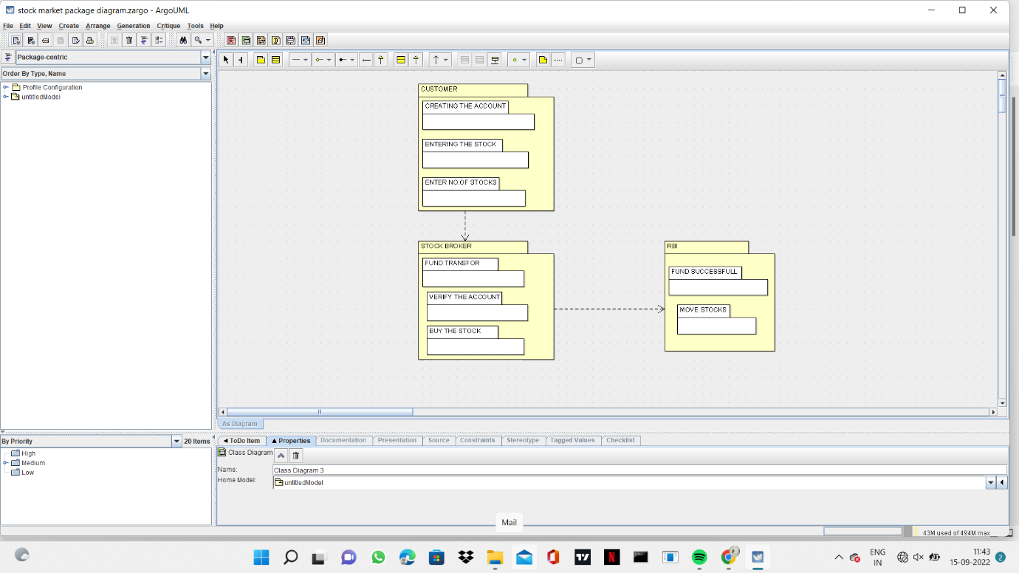

**ACTIVITY DIAGRAM:**

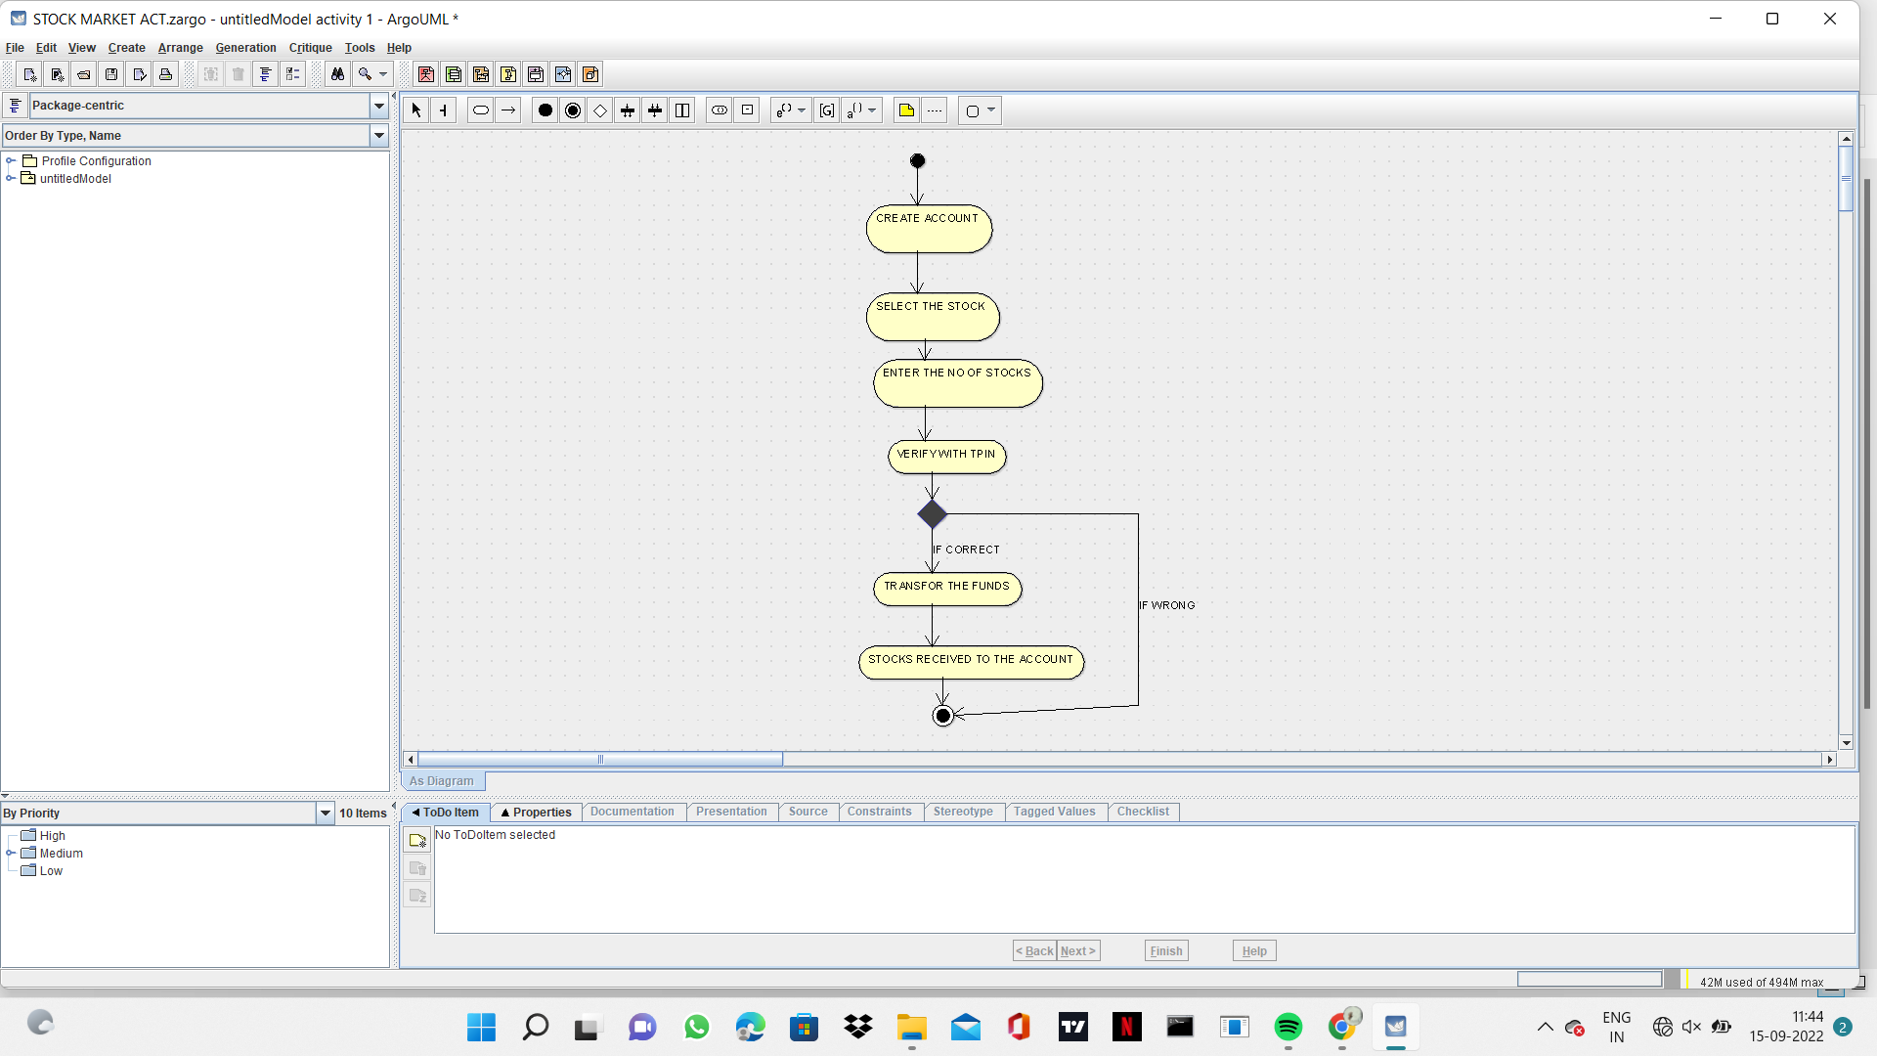

**COLLABORATION DIAGRAM**

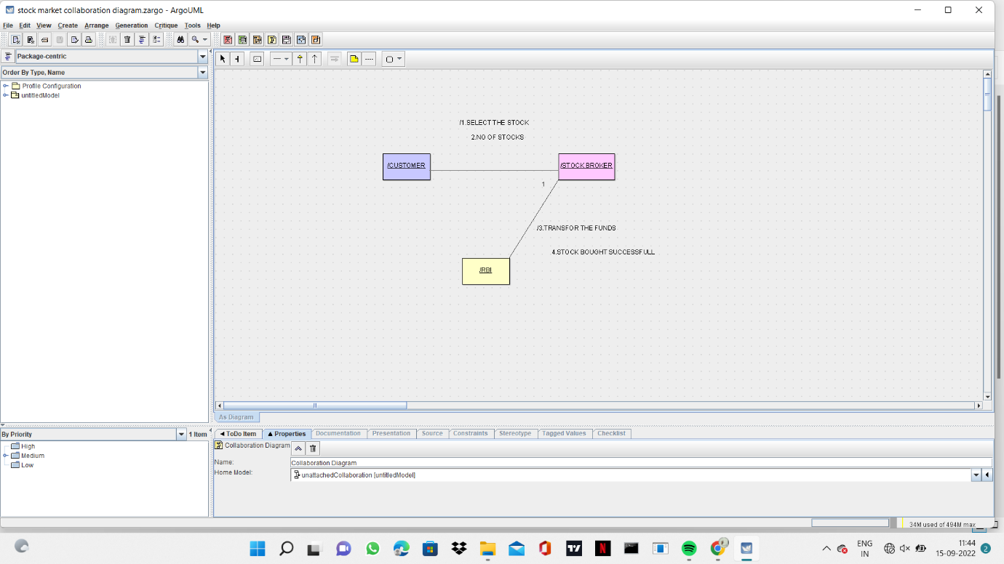

**COMPONENT DIAGRAM**

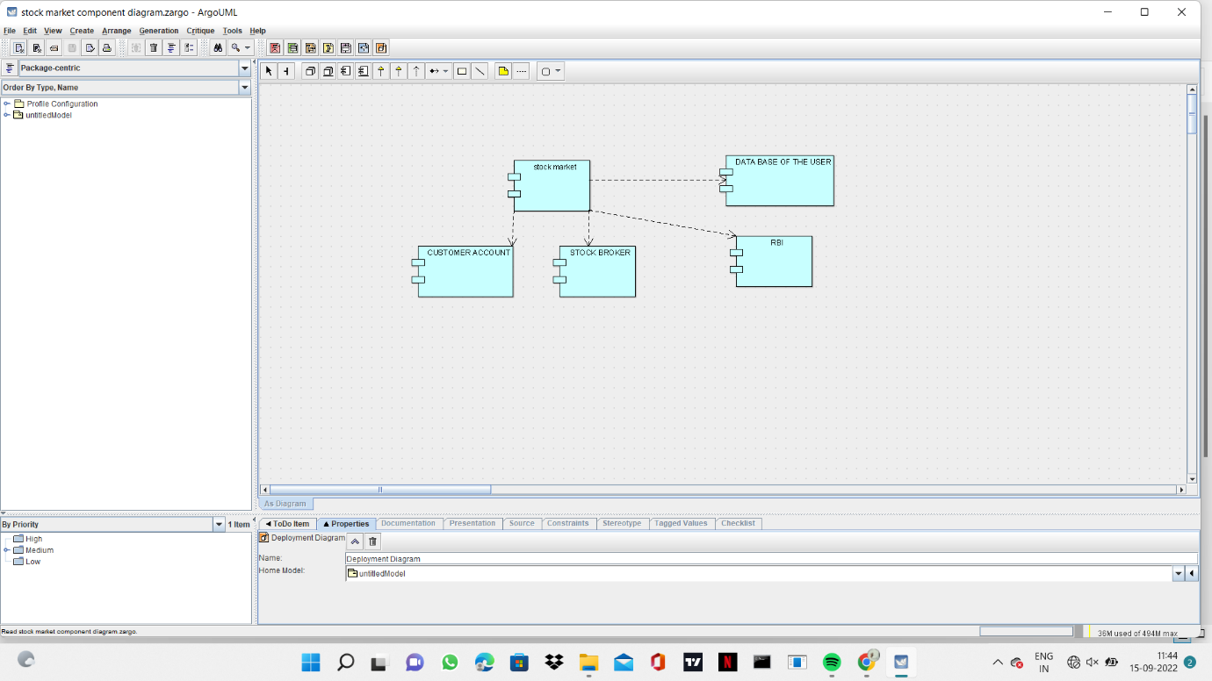

**DEPLOYMENT DIAGRAM**

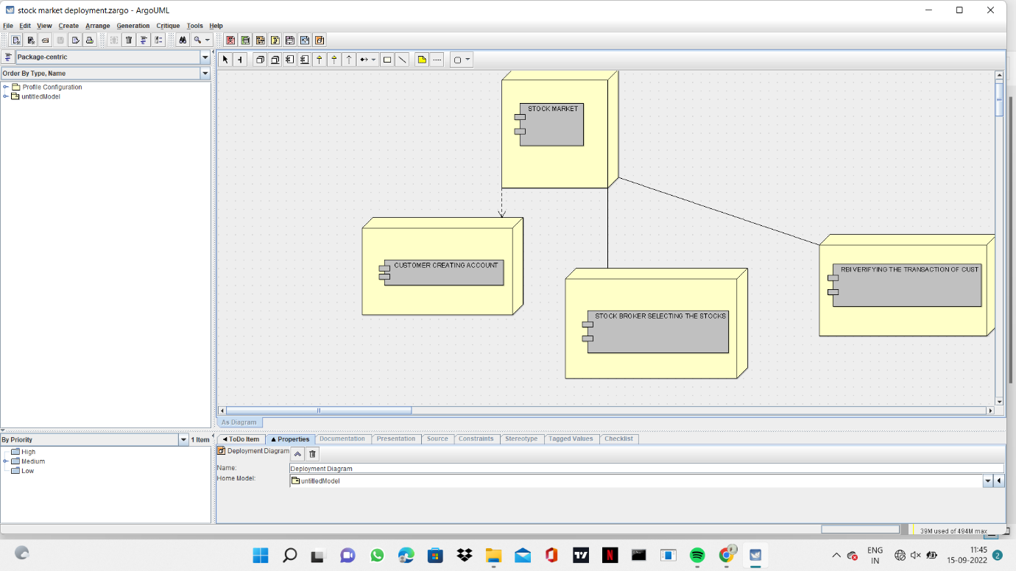

**USE CASE DIAGRAM**

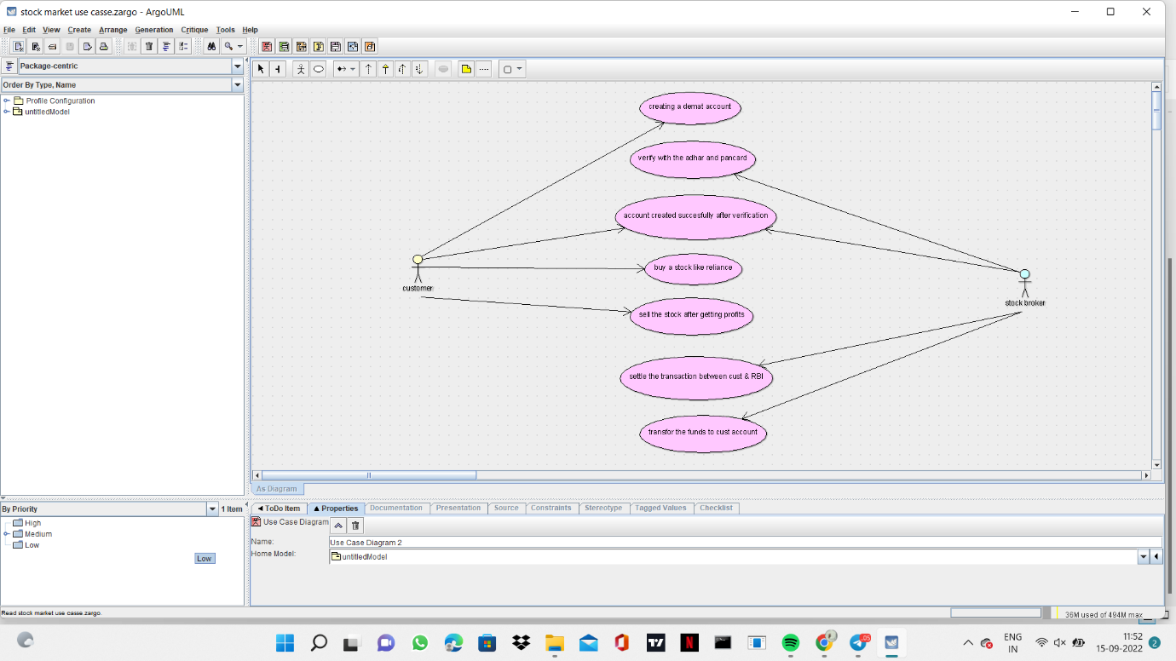

**CLASS DIAGRAM**

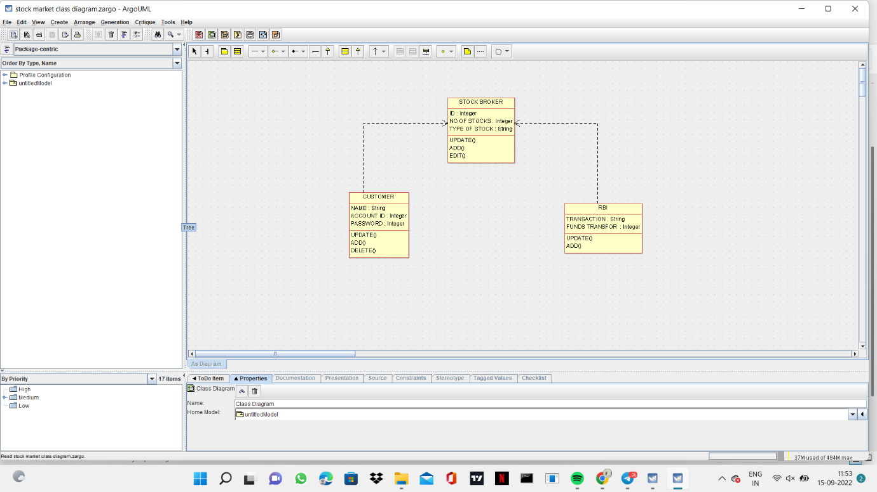

**SEQUENCE DIAGRAM**

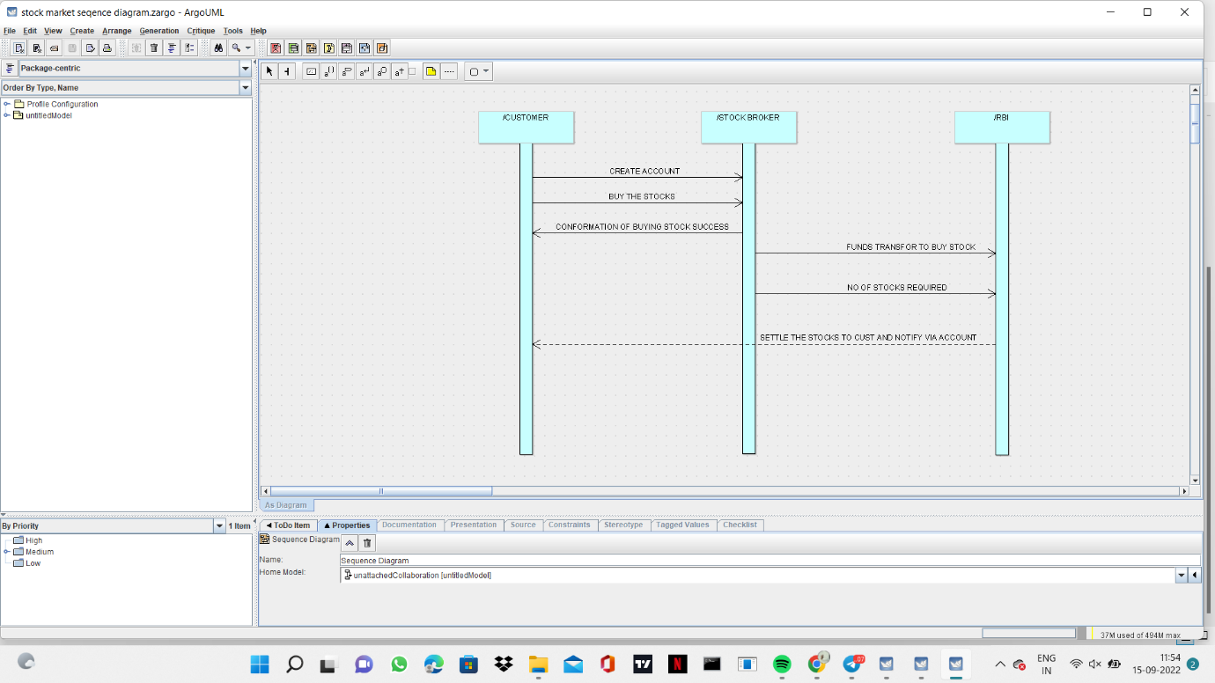

**STATE CHART DIAGRAM**

